**WORKSHEET WEEK 25. GRADE 5**

**UNIT 10**

**1 Write and match.**1 aglugeg  **luggage** **____e___**2 senpsaegr __________   
3 nyome ___________

4 zienagam __________  
5 varrlsia __________  
6 orspapts ___________

a.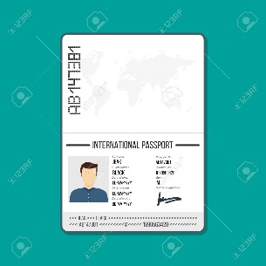 b.  c. 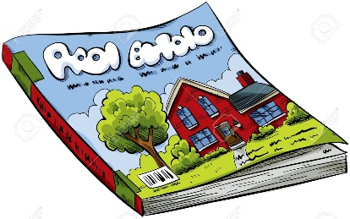

d.  e.  f .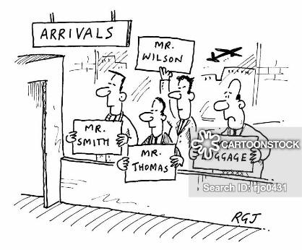

2. Complete the sentences. Write much or many.1 I haven’t got **much** time.  
2 Did you bring___________ luggage?  
3 There aren’t __________passengers on the plane.  
4 We don’t need to buy ________food.  
5 We won’t have to take _________money with us.  
6 Have you got __________suitcases?  
7 There aren’t _____________newspapers in the shop.  
8 I can’t see _____________hotels.

**3. Complete the sentences. Write *some* or *any*.**1 I’d like **some** ice cream.  
2 There aren’t _______flights until tomorrow.  
3 There are__________ of the people from our plane.  
4 Amy hasn’t brought ___________sun cream.  
5 Is there ______________information about our flight?  
6 I’ve got _____________cheese here. Are you hungry?  
7 There won’t be ____________shops near the hotel.  
8 Did you buy ______________souvenirs?  
9 She hasn’t got _____________luggage.  
10 Mum didn’t buy ______________bananas yesterday.

**4.** **Choose A or B**1 a.The shop on the ferry has got a lot of comics.   
 b.The shop on the ferry has got a lot comics.  
2 a.There were many children in the gift shop.  
 b.There were lots of children in the gift shop.  
3 a.How much of money have you got?  
 b.How much money have you got?  
4. a.Are there many people in the café?  
 b.Are there a lot people in the café?  
5. a.We haven’t got some ice cream.  
 b.We haven’t got any ice cream.  
6. aThere isn’t much information about the ferry.  
 b.There isn’t some information about the ferry.  
7. a.I can’t carry many luggage.  
 b.I can’t carry any luggage.

**5. Circle the correct words.  
1** I have **some** / **any** / **many** money.  
**2** Do you have **some** / **much** / **any** magazines?  
**3** Julie doesn’t have **some** / **many** / **much** food.  
**4** They don’t have **any** / **some** / **much** newspapers.  
**5** Adam has **many** / **some** / **any** luggage.  
**6** They don’t have **some** / **any** / **many** passports